**Data Leakage Detection**

**CONTENTS**

**1. INTRODUCTION**

**2. ORGANIZATION PROFILE**

**3. SYSTEM ANALYSIS**

**3.1 Existing System 3.2 Limitations**

**3.3 Proposed System**

**3.4 Advantages of proposed system**

**4. problem formulation**

**4.1 Objectives**

**4.2 Hardware Specification**

**4.3 Software Specification 4.4 Software Descriptions**

**5. SYSTEM DESIGN**

**5.1 Design Overview**

**5.2 Context Analysis Diagram**

**5.3 Data Flow Diagram**

**5.4 Architecture Design**

**6. SYSTEM TESTING**

**6.1 Unit Testing**

**6.2 Integration Testing**

**6.3 Acceptance Testing**

**7. SYSTEM IMPLMENTATION**

**8. CONCLUSION**

**10. BIBLIOGRAPHY**

**11. APPENDICES**

**APPENDIX A: SAMPLE SCREENS**

1. **INTRODUCTION**

In the course of doing business, sometimes sensitive data must be handed over to supposedly trusted third parties. For example, a hospital may give patient records to researchers who will devise new treatments. Similarly,

a company may have partnerships with other companies that require sharing customer data. Another enterprise may outsource its data processing, so data must be given to various other companies.We call the owner of the data the distributor and the supposedly trusted third parties the agents. Our goal is to detect when the distributor’s sensitive data has been leaked by agents, and if possible to identify the agent that leaked the data. We consider applications where the original sensitive data cannot be perturbed. Perturbation is a very useful technique where the data is modified and made “less sensitive” before being handed to agents. For example, one can add random noise to certain attributes, or one can replace exact values by ranges . However, in some cases it is important not to alter the original distributor’s data. For example, if an outsourcer is doing our payroll, he must have the exact salary and customer bank account numbers. If medical researchers will be treating patients (as opposed to simply computing statistics), they may need accurate data for the patients. Traditionally, leakage detection is handled by watermarking, e.g., a unique code is embedded in each distributed

copy. If that copy is later discovered in the hands of an unauthorized party, the leaker can be identified. Watermarks can be very useful in some cases, but again, involve some modification of the original data.

Furthermore, watermarks can sometimes be destroyed if the data recipient is malicious. In this paper we study unobtrusive techniques for detecting

leakage of a set of objects or records. Specifically, we study the following scenario: After giving a set of objects to agents, the distributor discovers some of those same objects in an unauthorized place. (For example, the data may be found on a web site, or may be obtained through a legal discovery process.) At this point the distributor can assess the likelihood that the leaked data came from one or more agents, as opposed to having

been independently gathered by other means. Using an analogy with cookies stolen from a cookie jar, if we catch Freddie with a single cookie, he can argue that a friend gave him the cookie. But if we catch Freddie with 5 cookies, it will be much harder for him to argue that his hands were not in the cookie jar. If the distributor sees “enough evidence” that an agent leaked data, he may stop doing business with him, or may initiate legal proceedings. In this paper we develop a model for assessing the “guilt” of agents. We also present algorithms for distributing objects to agents, in a way that improves our chances of identifying a leaker. Finally, we also consider the option of adding “fake” objects to the distributed set. Such objects do not correspond to real entities but appear realistic to the agents. In a sense, the fake objects acts as a type of watermark for the entire set, without modifying any individual members. If it turns out an agent was given one or more fake objects that were leaked, then the distributor can be more confident that agent was guilty.

# 1.ORGANISATION PROFILE

**skdotCom Technologies has a rich background in Software Development and continues its entire attention on achieving transcending excellence in the Development and Maintenance of Software Projects and Products in Many Areas. Some of them are ERP, Banking, Manufacturing, Insurance and Laying Emphasis on the Multimedia Projects. These projects are prevalent and have been distributed and implemented for clients world over. Major software Development Park at Kodambakkam, Chennai, India.**

**I.       Genesis**

**Elucidating the Aborigines of the Company, skdotCom Technologies, was initially dotCom IT Jobs Consultancy.**

**After stabilizing the skdotCom Products, Mr. P. Sivakumar M.C.A started giving Counseling Services in the name of skdotCom Agency, privately handled several Projects for leading Companies like Alstom, MRL and Spencers. DSEL has confronted challenges and rooted itself has a niche player in the Multimedia and the Business Software Segment. The Level of performed has been exemplary leaving it to nothing than the best of benchmark.**

**The indispensable factors, which give DSEL the competitive advantages over others in the market may be slated as :**

**•        Performance**

**•        Pioneering efforts**

**•        Client satisfaction**

**•        Innovative concepts**

**•        Constant Evaluations**

**•        Improvisation**

**•        Cost Effectiveness**

**II.    Comparison Mission Statement**

**“To help customer optimize their investments in information technology, to help them gain a competitive edge in the market place.”**

**III. Quality policy**

**“To help our stock holders by regularly reviewing and improving our process.”**

**IV.  Infrastructure**

**Nested in an area with built-in area of 2,400 sq.ft. The park has encountered itself with computing resources that include from IBM. Besides, it also houses HP/9000, Sun Sparch, DEC Alpha System and over 500 IBM PS/VP nodes over a Heterogeneous Fiber Optic Network. Operating system is used varied from MVS and Aix through OS/400 and OS/2 to SOLARIS, UNIX and Windows with range of RDBMS, Languages and Case tools.**

**Major Functions / Activities at skdotCom**

**Only a few years ago, the World Wide Web was a very design unfriendly place. But with the advent of Images, Web Pages have become Interactive. This inter-activity is still limited. In its endeavor to make the Internet more Interactive Exciting, skdotCom Technologies has set up the Internet Team.**

**3. SYSTEM ANALYSIS**

**EXISTING SYSTEM:**

Traditionally, leakage detection is handled by watermarking, e.g., a unique code is embedded in each distributed copy. If that copy is later discovered in the hands of an unauthorized party, the leaker can be identified. Watermarks can be very useful in some cases, but again, involve some modification of the original data. Furthermore, watermarks can sometimes be destroyed if the data recipient is malicious. *E.g*. A hospital may give patient records to researchers who will devise new treatments. Similarly, a company may have partnerships with other companies that require sharing customer data. Another enterprise may outsource its data processing, so data must be given to various other companies. We call the owner of the data the distributor and the supposedly trusted third parties the agents.

**PROPOSED SYSTEM:**

Our goal is to detect when the distributor’s sensitive data has been leaked by agents, and if possible to identify the agent that leaked the data. Perturbation is a very useful technique where the data is modified and made “less sensitive” before being handed to agents. we develop *unobtrusive* techniques for detecting leakage of a set of objects or records.

In this section we develop a model for assessing the “guilt” of agents. We also present algorithms for distributing objects to agents, in a way that improves our chances of identifying a leaker. Finally, we also consider the option of adding “fake” objects to the distributed set. Such objects do not correspond to real entities but appear realistic to the agents. In a sense, the fake objects acts as a type of watermark for the entire set, without modifying any individual members. If it turns out an agent was given one or more fake objects that were leaked, then the distributor can be more confident that agent was guilty.

**Problem Setup and Notation:**

A distributor owns a set T={t1,…,tm}of valuable data objects. The distributor wants to share some of the objects with a set of agents U1,U2,…Un, but does not wish the objects be leaked to other third parties. The objects in T could be of any type and size, e.g., they could be tuples in a relation, or relations in a database. An agent Ui receives a subset of objects, determined either by a sample request or an explicit request:

1. *Sample request*

2. *Explicit request*

**Guilt Model Analysis:**

our model parameters interact and to check if the interactions match our intuition, in this section we study two simple scenarios as **Impact of Probability** p and **Impact of Overlap between** Ri **and** S. In each scenario we have a target that has obtained all the distributor’s objects, i.e., T = S.

**Algorithms:**

**1. Evaluation of Explicit Data Request Algorithms**

In the first place, the goal of these experiments was to see whether fake objects in the distributed data sets yield significant improvement in our chances of detecting a guilty agent. In the second place, we wanted to evaluate our e-optimal algorithm relative to a random allocation.

**2. Evaluation of Sample Data Request Algorithms**

With sample data requests agents are not interested in particular objects. Hence, object sharing is not explicitly defined by their requests. The distributor is “forced” to allocate certain objects to multiple agents only if the number of requested objects exceeds the number of objects in set T. The more data objects the agents request in total, the more recipients on average an object has; and the more objects are shared among different agents, the more difficult it is to detect a guilty agent.

### IMPLEMENTATION

Implementation is the stage of the project when the theoretical design is turned out into a working system. Thus it can be considered to be the most critical stage in achieving a successful new system and in giving the user, confidence that the new system will work and be effective.

The implementation stage involves careful planning, investigation of the existing system and it’s constraints on implementation, designing of methods to achieve changeover and evaluation of changeover methods.

**Main Modules:-**

**MODULES**:

1. Data Allocation Module:

The main focus of our project is the data allocation problem as how can the distributor “intelligently” give data to agents in order to improve the chances of detecting a guilty agent.

2. Fake Object Module:

Fake objects are objects generated by the distributor in order to increase the chances of detecting agents that leak data. The distributor may be able to add fake objects to the distributed data in order to improve his effectiveness in detecting guilty agents. Our use of fake objects is inspired by the use of “trace” records in mailing lists.

3. Optimization Module:

The Optimization Module is the distributor’s data allocation to agents has one constraint and one objective. The distributor’s constraint is to satisfy agents’ requests, by providing them with the number of objects they request or with all available objects that satisfy their conditions. His objective is to be able to detect an agent who leaks any portion of his data.

4. Data Distributor:

A data distributor has given sensitive data to a set of supposedly trusted agents (third parties). Some of the data is leaked and found in an unauthorized place (e.g., on the web or somebody’s laptop). The distributor must assess the likelihood that the leaked data came from one or more agents, as opposed to having been independently gathered by other means.

**System Specification**

**System Requirements:**

**Hardware Requirements:**

* System : Pentium IV 2.4 GHz.
* Hard Disk : 40 GB.
* Floppy Drive : 1.44 Mb.
* Monitor : 15 VGA Colour.
* Mouse : Logitech.
* Ram : 512 Mb.

**Software Requirements:**

* Operating system : - Windows XP.
* Coding Language : DOT NET
* Data Base : SQL Server 2005

**2. SYSTEM STUDY**

**2.1 FEASIBILITY STUDY**

The feasibility of the project is analyzed in this phase and business proposal is put forth with a very general plan for the project and some cost estimates. During system analysis the feasibility study of the proposed system is to be carried out. This is to ensure that the proposed system is not a burden to the company. For feasibility analysis, some understanding of the major requirements for the system is essential.

Three key considerations involved in the feasibility analysis are

* ECONOMICAL FEASIBILITY
* TECHNICAL FEASIBILITY
* SOCIAL FEASIBILITY

**ECONOMICAL FEASIBILITY**

This study is carried out to check the economic impact that the system will have on the organization. The amount of fund that the company can pour into the research and development of the system is limited. The expenditures must be justified. Thus the developed system as well within the budget and this was achieved because most of the technologies used are freely available. Only the customized products had to be purchased.

### TECHNICAL FEASIBILITY

This study is carried out to check the technical feasibility, that is, the technical requirements of the system. Any system developed must not have a high demand on the available technical resources. This will lead to high demands on the available technical resources. This will lead to high demands being placed on the client. The developed system must have a modest requirement, as only minimal or null changes are required for implementing this system.

**SOCIAL FEASIBILITY**

The aspect of study is to check the level of acceptance of the system by the user. This includes the process of training the user to use the system efficiently. The user must not feel threatened by the system, instead must accept it as a necessity. The level of acceptance by the users solely depends on the methods that are employed to educate the user about the system and to make him familiar with it. His level of confidence must be raised so that he is also able to make some constructive criticism, which is welcomed, as he is the final user of the system.

**SYSTEM DESIGN**

**Data Flow Diagram / Use Case Diagram / Flow Diagram**

The DFD is also called as bubble chart. It is a simple graphical formalism that can be used to represent a system in terms of the input data to the system, various processing carried out on these data, and the output data is generated by the system.

Data flow diagram: **Data Flow Diagram:**



**Use Case Diagram:**



**Class Diagram:**



**Sequence Diagram:**



**Activity Diagram:**



### 6. SYSTEM TESTING

The purpose of testing is to discover errors. Testing is the process of trying to discover every conceivable fault or weakness in a work product. It provides a way to check the functionality of components, sub assemblies, assemblies and/or a finished product It is the process of exercising software with the intent of ensuring that the

Software system meets its requirements and user expectations and does not fail in an unacceptable manner. There are various types of test. Each test type addresses a specific testing requirement.

**TYPES OF TESTS**

**Unit testing**

Unit testing involves the design of test cases that validate that the internal program logic is functioning properly, and that program inputs produce valid outputs. All decision branches and internal code flow should be validated. It is the testing of individual software units of the application .it is done after the completion of an individual unit before integration. This is a structural testing, that relies on knowledge of its construction and is invasive. Unit tests perform basic tests at component level and test a specific business process, application, and/or system configuration. Unit tests ensure that each unique path of a business process performs accurately to the documented specifications and contains clearly defined inputs and expected results.

***Integration testing***

Integration tests are designed to test integrated software components to determine if they actually run as one program. Testing is event driven and is more concerned with the basic outcome of screens or fields. Integration tests demonstrate that although the components were individually satisfaction, as shown by successfully unit testing, the combination of components is correct and consistent. Integration testing is specifically aimed at exposing the problems that arise from the combination of components.

**Functional test**

Functional tests provide systematic demonstrations that functions tested are available as specified by the business and technical requirements, system documentation, and user manuals.

Functional testing is centered on the following items:

Valid Input : identified classes of valid input must be accepted.

Invalid Input : identified classes of invalid input must be rejected.

Functions : identified functions must be exercised.

Output : identified classes of application outputs must be exercised.

Systems/Procedures: interfacing systems or procedures must be invoked.

Organization and preparation of functional tests is focused on requirements, key functions, or special test cases. In addition, systematic coverage pertaining to identify Business process flows; data fields, predefined processes, and successive processes must be considered for testing. Before functional testing is complete, additional tests are identified and the effective value of current tests is determined.

**System Test**

System testing ensures that the entire integrated software system meets requirements. It tests a configuration to ensure known and predictable results. An example of system testing is the configuration oriented system integration test. System testing is based on process descriptions and flows, emphasizing pre-driven process links and integration points.

**White Box Testing**

White Box Testing is a testing in which in which the software tester has knowledge of the inner workings, structure and language of the software, or at least its purpose. It is purpose. It is used to test areas that cannot be reached from a black box level.

**Black Box Testing**

Black Box Testing is testing the software without any knowledge of the inner workings, structure or language of the module being tested. Black box tests, as most other kinds of tests, must be written from a definitive source document, such as specification or requirements document, such as specification or requirements document. It is a testing in which the software under test is treated, as a black box .you cannot “see” into it. The test provides inputs and responds to outputs without considering how the software works.

**6.1 Unit Testing:**

Unit testing is usually conducted as part of a combined code and unit test phase of the software lifecycle, although it is not uncommon for coding and unit testing to be conducted as two distinct phases.

**Test strategy and approach**

Field testing will be performed manually and functional tests will be written in detail.

**Test objectives**

* All field entries must work properly.
* Pages must be activated from the identified link.
* The entry screen, messages and responses must not be delayed.

**Features to be tested**

* Verify that the entries are of the correct format
* No duplicate entries should be allowed
* All links should take the user to the correct page.

# 6.2 Integration Testing

Software integration testing is the incremental integration testing of two or more integrated software components on a single platform to produce failures caused by interface defects.

The task of the integration test is to check that components or software applications, e.g. components in a software system or – one step up – software applications at the company level – interact without error.

**Test Results:** All the test cases mentioned above passed successfully. No defects encountered.

***6.3 Acceptance Testing***

User Acceptance Testing is a critical phase of any project and requires significant participation by the end user. It also ensures that the system meets the functional requirements.

**Test Results:** All the test cases mentioned above passed successfully. No defects encountered.

**Software Environment**

## *Java Technology*

Java technology is both a programming language and a platform.

### The Java Programming Language

### The Java programming language is a high-level language that can be characterized by all of the following buzzwords:

* + - Simple
    - Architecture neutral
    - Object oriented
    - Portable
    - Distributed
    - High performance
    - Interpreted
    - Multithreaded
    - Robust
    - Dynamic
    - Secure

With most programming languages, you either compile or interpret a program so that you can run it on your computer. The Java programming language is unusual in that a program is both compiled and interpreted. With the compiler, first you translate a program into an intermediate language called Java byte codes —the platform-independent codes interpreted by the interpreter on the Java platform. The interpreter parses and runs each Java byte code instruction on the computer. Compilation happens just once; interpretation occurs each time the program is executed. The following figure illustrates how this works.

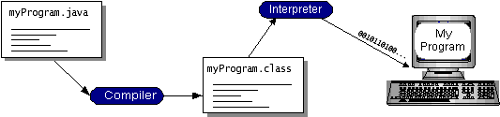

You can think of Java byte codes as the machine code instructions for the Java Virtual Machine (Java VM). Every Java interpreter, whether it’s a development tool or a Web browser that can run applets, is an implementation of the Java VM. Java byte codes help make “write once, run anywhere” possible. You can compile your program into byte codes on any platform that has a Java compiler. The byte codes can then be run on any implementation of the Java VM. That means that as long as a computer has a Java VM, the same program written in the Java programming language can run on Windows 2000, a Solaris workstation, or on an iMac.

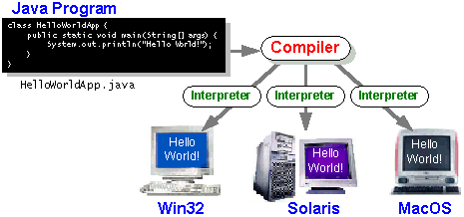

### The Java Platform

A platform is the hardware or software environment in which a program runs. We’ve already mentioned some of the most popular platforms like Windows 2000, Linux, Solaris, and MacOS. Most platforms can be described as a combination of the operating system and hardware. The Java platform differs from most other platforms in that it’s a software-only platform that runs on top of other hardware-based platforms.

The Java platform has two components:

* The Java Virtual Machine (Java VM)
* The Java Application Programming Interface (Java API)

You’ve already been introduced to the Java VM. It’s the base for the Java platform and is ported onto various hardware-based platforms.

The Java API is a large collection of ready-made software components that provide many useful capabilities, such as graphical user interface (GUI) widgets. The Java API is grouped into libraries of related classes and interfaces; these libraries are known as packages. The next section, What Can Java Technology Do? Highlights what functionality some of the packages in the Java API provide.

The following figure depicts a program that’s running on the Java platform. As the figure shows, the Java API and the virtual machine insulate the program from the hardware.

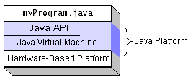

Native code is code that after you compile it, the compiled code runs on a specific hardware platform. As a platform-independent environment, the Java platform can be a bit slower than native code. However, smart compilers, well-tuned interpreters, and just-in-time byte code compilers can bring performance close to that of native code without threatening portability.

## What Can Java Technology Do?

The most common types of programs written in the Java programming language are applets and applications. If you’ve surfed the Web, you’re probably already familiar with applets. An applet is a program that adheres to certain conventions that allow it to run within a Java-enabled browser.

However, the Java programming language is not just for writing cute, entertaining applets for the Web. The general-purpose, high-level Java programming language is also a powerful software platform. Using the generous API, you can write many types of programs.

An application is a standalone program that runs directly on the Java platform. A special kind of application known as a server serves and supports clients on a network. Examples of servers are Web servers, proxy servers, mail servers, and print servers. Another specialized program is a servlet. A servlet can almost be thought of as an applet that runs on the server side. Java Servlets are a popular choice for building interactive web applications, replacing the use of CGI scripts. Servlets are similar to applets in that they are runtime extensions of applications. Instead of working in browsers, though, servlets run within Java Web servers, configuring or tailoring the server.

How does the API support all these kinds of programs? It does so with packages of software components that provides a wide range of functionality. Every full implementation of the Java platform gives you the following features:

* **The essentials**: Objects, strings, threads, numbers, input and output, data structures, system properties, date and time, and so on.
* **Applets**: The set of conventions used by applets.
* **Networking**: URLs, TCP (Transmission Control Protocol), UDP (User Data gram Protocol) sockets, and IP (Internet Protocol) addresses.
* **Internationalization**: Help for writing programs that can be localized for users worldwide. Programs can automatically adapt to specific locales and be displayed in the appropriate language.
* **Security**: Both low level and high level, including electronic signatures, public and private key management, access control, and certificates.
* **Software components**: Known as JavaBeansTM, can plug into existing component architectures.
* **Object serialization**: Allows lightweight persistence and communication via Remote Method Invocation (RMI).
* **Java Database Connectivity (JDBCTM)**: Provides uniform access to a wide range of relational databases.

The Java platform also has APIs for 2D and 3D graphics, accessibility, servers, collaboration, telephony, speech, animation, and more. The following figure depicts what is included in the Java 2 SDK.

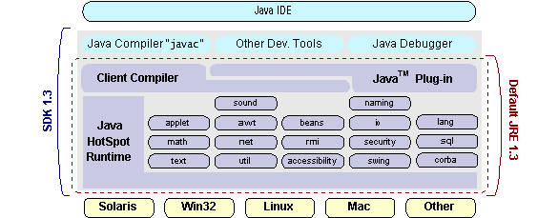

## How Will Java Technology Change My Life?

We can’t promise you fame, fortune, or even a job if you learn the Java programming language. Still, it is likely to make your programs better and requires less effort than other languages. We believe that Java technology will help you do the following:

* **Get started quickly**: Although the Java programming language is a powerful object-oriented language, it’s easy to learn, especially for programmers already familiar with C or C++.
* **Write less code**: Comparisons of program metrics (class counts, method counts, and so on) suggest that a program written in the Java programming language can be four times smaller than the same program in C++.
* **Write better code**: The Java programming language encourages good coding practices, and its garbage collection helps you avoid memory leaks. Its object orientation, its JavaBeans component architecture, and its wide-ranging, easily extendible API let you reuse other people’s tested code and introduce fewer bugs.
* **Develop programs more quickly**: Your development time may be as much as twice as fast versus writing the same program in C++. Why? You write fewer lines of code and it is a simpler programming language than C++.
* **Avoid platform dependencies with 100% Pure Java**: You can keep your program portable by avoiding the use of libraries written in other languages. The 100% Pure JavaTM Product Certification Program has a repository of historical process manuals, white papers, brochures, and similar materials online.
* **Write once, run anywhere**: Because 100% Pure Java programs are compiled into machine-independent byte codes, they run consistently on any Java platform.
* **Distribute software more easily**: You can upgrade applets easily from a central server. Applets take advantage of the feature of allowing new classes to be loaded “on the fly,” without recompiling the entire program.

### ODBC

Microsoft Open Database Connectivity (ODBC) is a standard programming interface for application developers and database systems providers. Before ODBC became a *de facto* standard for Windows programs to interface with database systems, programmers had to use proprietary languages for each database they wanted to connect to. Now, ODBC has made the choice of the database system almost irrelevant from a coding perspective, which is as it should be. Application developers have much more important things to worry about than the syntax that is needed to port their program from one database to another when business needs suddenly change.

Through the ODBC Administrator in Control Panel, you can specify the particular database that is associated with a data source that an ODBC application program is written to use. Think of an ODBC data source as a door with a name on it. Each door will lead you to a particular database. For example, the data source named Sales Figures might be a SQL Server database, whereas the Accounts Payable data source could refer to an Access database. The physical database referred to by a data source can reside anywhere on the LAN.

The ODBC system files are not installed on your system by Windows 95. Rather, they are installed when you setup a separate database application, such as SQL Server Client or Visual Basic 4.0. When the ODBC icon is installed in Control Panel, it uses a file called ODBCINST.DLL. It is also possible to administer your ODBC data sources through a stand-alone program called ODBCADM.EXE. There is a 16-bit and a 32-bit version of this program and each maintains a separate list of ODBC data sources.

From a programming perspective, the beauty of ODBC is that the application can be written to use the same set of function calls to interface with any data source, regardless of the database vendor. The source code of the application doesn’t change whether it talks to Oracle or SQL Server. We only mention these two as an example. There are ODBC drivers available for several dozen popular database systems. Even Excel spreadsheets and plain text files can be turned into data sources. The operating system uses the Registry information written by ODBC Administrator to determine which low-level ODBC drivers are needed to talk to the data source (such as the interface to Oracle or SQL Server). The loading of the ODBC drivers is transparent to the ODBC application program. In a client/server environment, the ODBC API even handles many of the network issues for the application programmer.

The advantages of this scheme are so numerous that you are probably thinking there must be some catch. The only disadvantage of ODBC is that it isn’t as efficient as talking directly to the native database interface. ODBC has had many detractors make the charge that it is too slow. Microsoft has always claimed that the critical factor in performance is the quality of the driver software that is used. In our humble opinion, this is true. The availability of good ODBC drivers has improved a great deal recently. And anyway, the criticism about performance is somewhat analogous to those who said that compilers would never match the speed of pure assembly language. Maybe not, but the compiler (or ODBC) gives you the opportunity to write cleaner programs, which means you finish sooner. Meanwhile, computers get faster every year.

**JDBC**

In an effort to set an independent database standard API for Java; Sun Microsystems developed Java Database Connectivity, or JDBC. JDBC offers a generic SQL database access mechanism that provides a consistent interface to a variety of RDBMSs. This consistent interface is achieved through the use of “plug-in” database connectivity modules, or *drivers*. If a database vendor wishes to have JDBC support, he or she must provide the driver for each platform that the database and Java run on.

To gain a wider acceptance of JDBC, Sun based JDBC’s framework on ODBC. As you discovered earlier in this chapter, ODBC has widespread support on a variety of platforms. Basing JDBC on ODBC will allow vendors to bring JDBC drivers to market much faster than developing a completely new connectivity solution.

JDBC was announced in March of 1996. It was released for a 90 day public review that ended June 8, 1996. Because of user input, the final JDBC v1.0 specification was released soon after.

The remainder of this section will cover enough information about JDBC for you to know what it is about and how to use it effectively. This is by no means a complete overview of JDBC. That would fill an entire book.

### JDBC Goals

Few software packages are designed without goals in mind. JDBC is one that, because of its many goals, drove the development of the API. These goals, in conjunction with early reviewer feedback, have finalized the JDBC class library into a solid framework for building database applications in Java.

The goals that were set for JDBC are important. They will give you some insight as to why certain classes and functionalities behave the way they do. The eight design goals for JDBC are as follows:

1. ***SQL Level API***

The designers felt that their main goal was to define a SQL interface for Java. Although not the lowest database interface level possible, it is at a low enough level for higher-level tools and APIs to be created. Conversely, it is at a high enough level for application programmers to use it confidently. Attaining this goal allows for future tool vendors to “generate” JDBC code and to hide many of JDBC’s complexities from the end user.

1. ***SQL Conformance***

SQL syntax varies as you move from database vendor to database vendor. In an effort to support a wide variety of vendors, JDBC will allow any query statement to be passed through it to the underlying database driver. This allows the connectivity module to handle non-standard functionality in a manner that is suitable for its users.

1. ***JDBC must be implemental on top of common database interfaces***The JDBC SQL API must “sit” on top of other common SQL level APIs. This goal allows JDBC to use existing ODBC level drivers by the use of a software interface. This interface would translate JDBC calls to ODBC and vice versa.
2. ***Provide a Java interface that is consistent with the rest of the Java system***

Because of Java’s acceptance in the user community thus far, the designers feel that they should not stray from the current design of the core Java system.

1. ***Keep it simple***

This goal probably appears in all software design goal listings. JDBC is no exception. Sun felt that the design of JDBC should be very simple, allowing for only one method of completing a task per mechanism. Allowing duplicate functionality only serves to confuse the users of the API.

1. ***Use strong, static typing wherever possible***

Strong typing allows for more error checking to be done at compile time; also, less error appear at runtime.

1. ***Keep the common cases simple***

Because more often than not, the usual SQL calls used by the programmer are simple SELECT’s, INSERT’s, DELETE’s and UPDATE’s, these queries should be simple to perform with JDBC. However, more complex SQL statements should also be possible.

Finally we decided to proceed the implementation using Java Networking.

And for dynamically updating the cache table we go for MS Access database.

Java ha two things: a programming language and a platform.

Java is a high-level programming language that is all of the following

Simple Architecture-neutral

Object-oriented Portable

Distributed High-performance

Interpreted multithreaded

Robust Dynamic

Secure

Java is also unusual in that each Java program is both compiled and interpreted. With a compile you translate a Java program into an intermediate language called Java byte codes the platform-independent code instruction is passed and run on the computer.

Compilation happens just once; interpretation occurs each time the program is executed. The figure illustrates how this works.

**Java Program**

**Compilers**

**Interpreter**

**My Program**

You can think of Java byte codes as the machine code instructions for the Java Virtual Machine (Java VM). Every Java interpreter, whether it’s a Java development tool or a Web browser that can run Java applets, is an implementation of the Java VM. The Java VM can also be implemented in hardware.

Java byte codes help make “write once, run anywhere” possible. You can compile your Java program into byte codes on my platform that has a Java compiler. The byte codes can then be run any implementation of the Java VM. For example, the same Java program can run Windows NT, Solaris, and Macintosh.

## Networking

### TCP/IP stack

The TCP/IP stack is shorter than the OSI one:

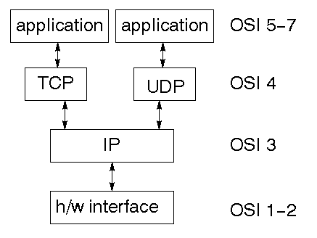

TCP is a connection-oriented protocol; UDP (User Datagram Protocol) is a connectionless protocol.

### IP datagram’s

The IP layer provides a connectionless and unreliable delivery system. It considers each datagram independently of the others. Any association between datagram must be supplied by the higher layers. The IP layer supplies a checksum that includes its own header. The header includes the source and destination addresses. The IP layer handles routing through an Internet. It is also responsible for breaking up large datagram into smaller ones for transmission and reassembling them at the other end.

### UDP

UDP is also connectionless and unreliable. What it adds to IP is a checksum for the contents of the datagram and port numbers. These are used to give a client/server model - see later.

### TCP

TCP supplies logic to give a reliable connection-oriented protocol above IP. It provides a virtual circuit that two processes can use to communicate.

### Internet addresses

In order to use a service, you must be able to find it. The Internet uses an address scheme for machines so that they can be located. The address is a 32 bit integer which gives the IP address. This encodes a network ID and more addressing. The network ID falls into various classes according to the size of the network address.

### Network address

Class A uses 8 bits for the network address with 24 bits left over for other addressing. Class B uses 16 bit network addressing. Class C uses 24 bit network addressing and class D uses all 32.

### Subnet address

Internally, the UNIX network is divided into sub networks. Building 11 is currently on one sub network and uses 10-bit addressing, allowing 1024 different hosts.

### Host address

8 bits are finally used for host addresses within our subnet. This places a limit of 256 machines that can be on the subnet.

### Total address

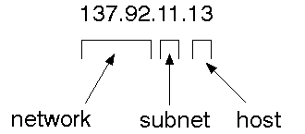

The 32 bit address is usually written as 4 integers separated by dots.

### Port addresses

A service exists on a host, and is identified by its port. This is a 16 bit number. To send a message to a server, you send it to the port for that service of the host that it is running on. This is not location transparency! Certain of these ports are "well known".

### Sockets

A socket is a data structure maintained by the system to handle network connections. A socket is created using the call socket. It returns an integer that is like a file descriptor. In fact, under Windows, this handle can be used with Read File and Write File functions.

#include <sys/types.h>

#include <sys/socket.h>

int socket(int family, int type, int protocol);

Here "family" will be AF_INET for IP communications, protocol will be zero, and type will depend on whether TCP or UDP is used. Two processes wishing to communicate over a network create a socket each. These are similar to two ends of a pipe - but the actual pipe does not yet exist.

**JFree Chart**

JFreeChart is a free 100% Java chart library that makes it easy for developers to display professional quality charts in their applications. JFreeChart's extensive feature set includes:

A consistent and well-documented API, supporting a wide range of chart types;

A flexible design that is easy to extend, and targets both server-side and client-side applications;

Support for many output types, including Swing components, image files (including PNG and JPEG), and vector graphics file formats (including PDF, EPS and SVG);

JFreeChart is "open source" or, more specifically, [free software](http://www.gnu.org/philosophy/free-sw.html). It is distributed under the terms of the [GNU Lesser General Public Licence](http://www.gnu.org/licenses/lgpl.html) (LGPL), which permits use in proprietary applications.

## 1. Map Visualizations

Charts showing values that relate to geographical areas. Some examples include: (a) population density in each state of the United States, (b) income per capita for each country in Europe, (c) life expectancy in each country of the world. The tasks in this project include:

Sourcing freely redistributable vector outlines for the countries of the world, states/provinces in particular countries (USA in particular, but also other areas);

Creating an appropriate dataset interface (plus default implementation), a rendered, and integrating this with the existing XYPlot class in JFreeChart;

Testing, documenting, testing some more, documenting some more.

## 2. Time Series Chart Interactivity

Implement a new (to JFreeChart) feature for interactive time series charts --- to display a separate control that shows a small version of ALL the time series data, with a sliding "view" rectangle that allows you to select the subset of the time series data to display in the main chart.

## 3. Dashboards

There is currently a lot of interest in dashboard displays. Create a flexible dashboard mechanism that supports a subset of JFreeChart chart types (dials, pies, thermometers, bars, and lines/time series) that can be delivered easily via both Java Web Start and an applet.

## 4. Property Editors

The property editor mechanism in JFreeChart only handles a small subset of the properties that can be set for charts. Extend (or reimplement) this mechanism to provide greater end-user control over the appearance of the charts.

# Tomcat 6.0 web server

Tomcat is an open source web server developed by Apache Group. Apache Tomcat is the servlet container that is used in the official Reference Implementation for the Java Servlet and JavaServer Pages technologies. The Java Servlet and JavaServer Pages specifications are developed by Sun under the Java Community Process. Web Servers like Apache Tomcat support only web components while an application server supports web components as well as business components (BEAs Weblogic, is one of the popular application server).To develop a web application with jsp/servlet install any web server like JRun, Tomcat etc to run your application.

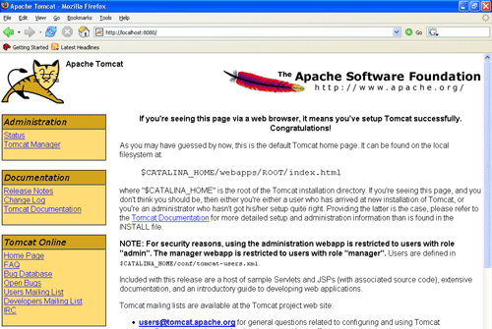

Fig Tomcat Webserver

**8. CONCLUSION**

In a perfect world there would be no need to hand over sensitive data to agents that may unknowingly or maliciously leak it. And even if we had to hand over sensitive data, in a perfect world we could watermark each object so that we could trace its origins with absolute certainty. However, in many cases we must indeed work with agents that may not be 100% trusted, and we may not be certain if a leaked object came from an agent or from some other source, since certain data cannot admit watermarks. In spite of these difficulties, we have shown it is possible to assess the likelihood that an agent is responsible for a leak, based on the overlap of his data with the leaked data and the data of other agents, and based on the probability that objects can be “guessed” by other means. Our model is relatively simple, but we believe it captures the essential trade-offs. The algorithms we have presented implement a variety of data distribution strategies that can improve the distributor’s chances of identifying a leaker. We have shown that distributing objects judiciously can make a significant difference in identifying guilty agents, especially in cases where there is large overlap in the data that agents must receive. Our future work includes the investigation of agent guilt models that capture leakage scenarios that are not studied in this paper. For example, what is the appropriate model for cases where agents can collude and identify fake tuples? A preliminary discussion of such a model is available in Another open problem is the extension of our allocation strategies so that they can handle agent requests in an online fashion (the presented strategies assume that there is a fixed set of agents with requests known in advance).

**10. BIBLIOGRAPHY**

Good Teachers are worth more than thousand books, we have them in Our Department

**References Made From:**

1. User Interfaces in C#: Windows Forms and Custom Controls by Matthew MacDonald.
2. Applied Microsoft® .NET Framework Programming (Pro-Developer) by Jeffrey Richter.
3. Practical .Net2 and C#2: Harness the Platform, the Language, and the Framework by Patrick Smacchia.
4. Data Communications and Networking, by Behrouz A Forouzan.
5. Computer Networking: A Top-Down Approach, by James F. Kurose.
6. Operating System Concepts, by Abraham Silberschatz.
7. R. Agrawal and J. Kiernan. Watermarking relational databases. In VLDB ’02: Proceedings of the 28th international conference on Very Large Data Bases, pages 155–166. VLDB Endowment, 2002.
8. P. Bonatti, S. D. C. di Vimercati, and P. Samarati. An algebra for composing access control policies. ACM Trans. Inf. Syst. Secur., 5(1):1–35, 2002.
9. P. Buneman, S. Khanna, and W. C. Tan. Why and where: A characterization of data provenance. In J. V. den Bussche and V. Vianu, editors, Database Theory - ICDT 2001, 8th International Conference, London, UK, January 4-6, 2001, Proceedings, volume 1973 of Lecture Notes in Computer Science, pages 316–330. Springer, 2001
10. P. Buneman and W.-C. Tan. Provenance in databases. In SIGMOD ’07: Proceedings of the 2007 ACM SIGMOD international conference on Management of data, pages 1171–1173, New York, NY, USA, 2007. ACM.
11. Y. Cui and J. Widom. Lineage tracing for general data warehouse transformations. In The VLDB Journal, pages 471–480, 2001.
12. S. Czerwinski, R. Fromm, and T. Hodes. Digital music distribution and audio watermarking.
13. F. Guo, J. Wang, Z. Zhang, X. Ye, and D. Li. Information Security Applications, pages 138–149. Springer, Berlin / Heidelberg, 2006. An Improved Algorithm to Watermark Numeric Relational Data.
14. F. Hartung and B. Girod. Watermarking of uncompressed and compressed video. Signal Processing, 66(3):283–301, 1998.
15. S. Jajodia, P. Samarati, M. L. Sapino, and V. S. Subrahmanian. Flexible support for multiple access control policies. ACM Trans. Database Syst., 26(2):214–260, 2001.
16. Y. Li, V. Swarup, and S. Jajodia. Fingerprinting relational databases: Schemes and specialties. IEEE Transactions on Dependable and Secure Computing, 02(1):34–45, 2005.
17. B. Mungamuru and H. Garcia-Molina. Privacy, preservation and performance: The 3 p’s of distributed data management. Technical report, Stanford University, 2008.

**Sites Referred:**

<http://www.sourcefordgde.com>

<http://www.networkcomputing.com/>

<http://www.ieee.org>

<http://www.almaden.ibm.com/software/quest/Resources/>

<http://www.computer.org/publications/dlib>

<http://www.ceur-ws.org/Vol-90/>

<http://www.microsoft.com/isapi/redir.dll?prd=ie&pver=6&ar=msnhome>

**Abbreviations:**

**OOPS 🡪 Object Oriented Programming Concepts**

**TCP/IP 🡪 Transmission Control Protocol/Internet Protocol**

**CLR 🡪 Common Language Runtime**

1. Data Allocation Module:

The main focus of our project is the data allocation problem as how can the distributor “intelligently” give data to agents in order to improve the chances of detecting a guilty agent.

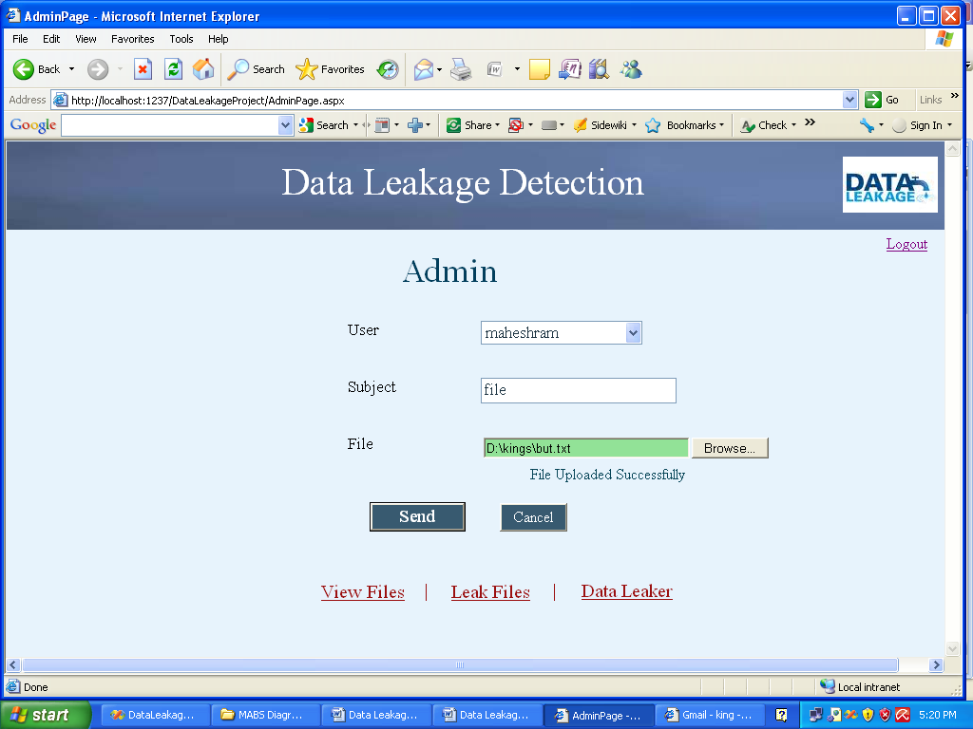

2. Fake Object Module:

Fake objects are objects generated by the distributor in order to increase the chances of detecting agents that leak data. The distributor may be able to add fake objects to the distributed data in order to improve his effectiveness in detecting guilty agents. Our use of fake objects is inspired by the use of “trace” records in mailing lists.

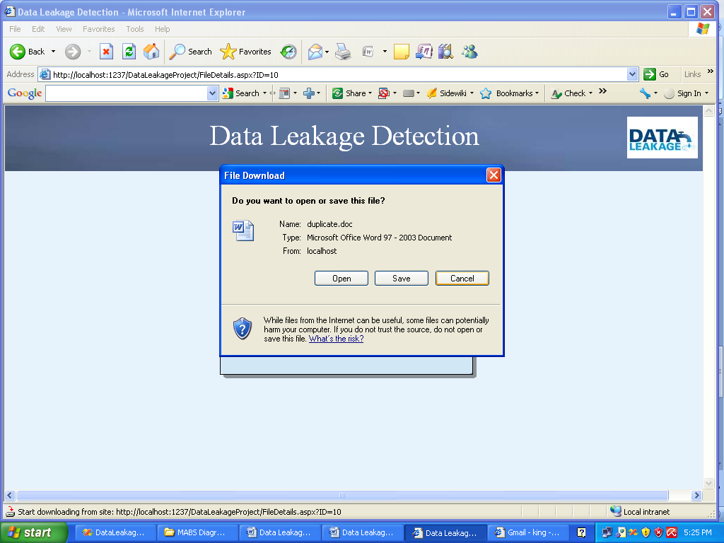

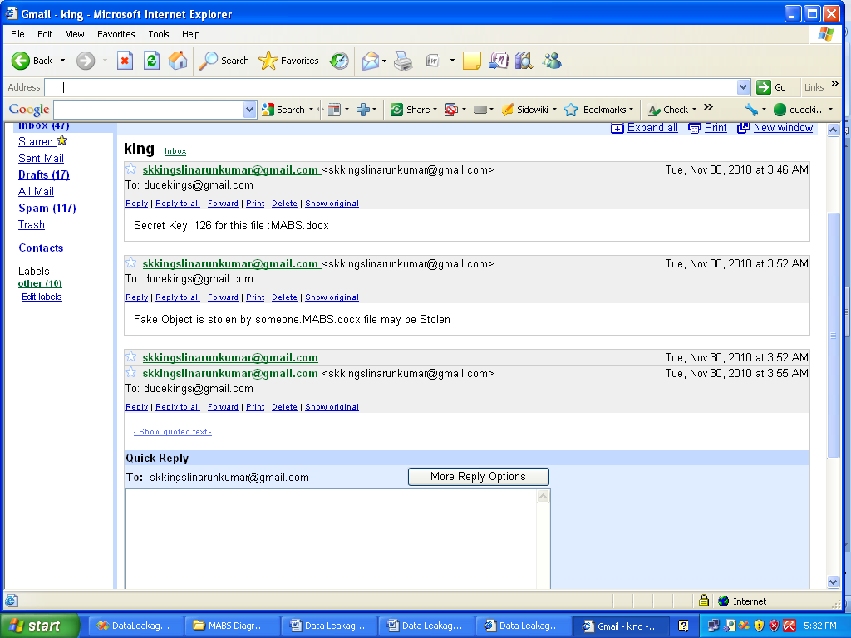

3. Optimization Module:

The Optimization Module is the distributor’s data allocation to agents has one constraint and one objective. The distributor’s constraint is to satisfy agents’ requests, by providing them with the number of objects they request or with all available objects that satisfy their conditions. His objective is to be able to detect an agent who leaks any portion of his data.

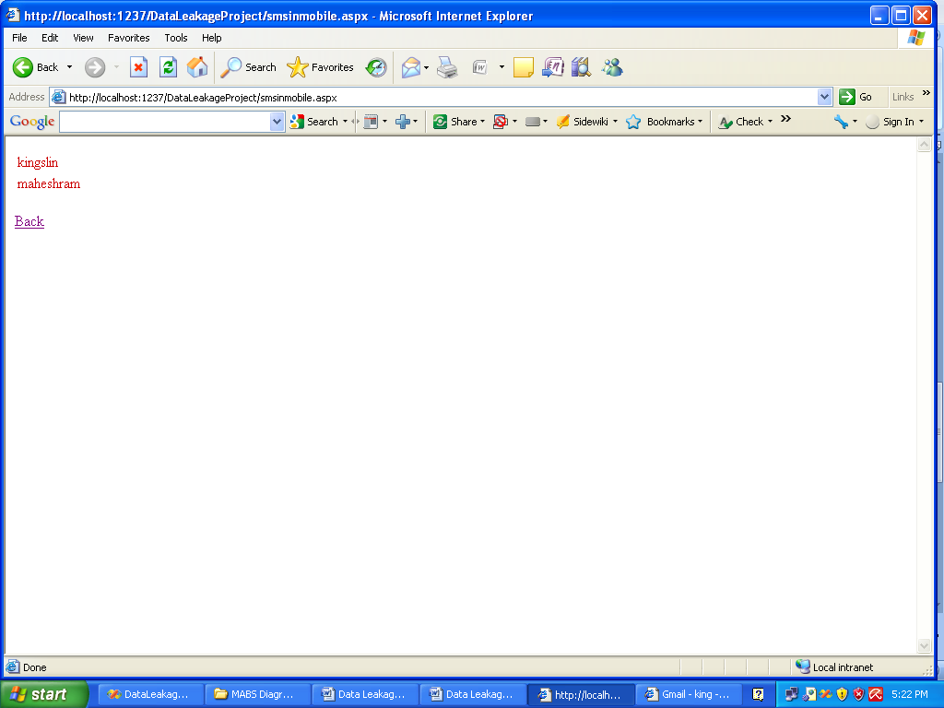

4. Data Distributor:

A data distributor has given sensitive data to a set of supposedly trusted agents (third parties). Some of the data is leaked and found in an unauthorized place (e.g., on the web or somebody’s laptop). The distributor must assess the likelihood that the leaked data came from one or more agents, as opposed to having been independently gathered by other means.

